StudioFlow
Milestone 2 — Documentation and Front-End Progress
MOD8 — Advanced Web Programming
Team: Raphaël, Théodore, Guillaume
Repository: github.com/ElpharienPY/StudioFlow
1. Front-End Progress
2. Updated Wireframes
3. Project Plan Update
4. Code Submission

1. Front-End Progress
Since Milestone 1, we built out the full front-end shell: a Vue 3 application (Vite, Vue Router) covering every screen from our vertical split — Auth & Team, Boards & Tasks, and Projects & Deliverables. There's no back-end yet (that's Milestone 3), so the app runs against mock data shaped exactly like our db/schema.sql tables — same field names, same enum values — so wiring up the real API later should mean rewriting what's inside a handful of store functions, not restructuring the front-end.
State management: plain Vue, no library
stores/auth.js and stores/projects.js are the single source of truth for session state and all the mock project/task/deliverable data. We first reached for Pinia, the standard choice for this in the Vue ecosystem, but it wasn't pulling its weight for an app this size — Vue's own reactive() already gives the same pattern (a shared, reactive singleton with getters and actions) without an extra dependency, so we dropped Pinia in favor of plain Vue reactivity.
What's working end to end
- Auth & Team (Raphaël's vertical): sign in / sign up with validation, a mock session persisted in localStorage, a route guard protecting every screen, and a Team page where project owners can invite members, change roles (owner / editor / viewer), or remove someone — read-only for everyone else.
- Boards & Tasks: a Kanban board (To Do / Doing / Done) per deliverable; a task detail panel with an editable production stage and a live comment thread.
- Projects & Deliverables: a Projects dashboard with status, progress, and team avatars per project; a deliverable view with a production-stage stepper (concept → script → shooting → editing → thumbnail → publishing) computed live from its tasks, an assets list with version numbers, and a project-wide Assets page.
Styling: plain CSS, not a framework
The brief allows vanilla CSS, Bootstrap, or Tailwind. We initially reached for Tailwind, since it's a fast fit for the mockups' dark, custom design system. We switched to plain CSS instead: one scoped style block per component, with the design system (colors, spacing, radii) centralized as CSS custom properties. It keeps the setup simple and means no one on the team needs to learn a utility-class framework before touching these files.
Two dev-only details worth flagging
While iterating, we added a "⚡ Dev sign-in" button on the login screen that signs in instantly as a seed user — reloading the app dozens of times a day and retyping credentials each time tested nothing, since mock auth has no real backend to check against yet. It's gated behind import.meta.env.DEV and is compiled out of npm run build, so it never reaches the graded build.
We also kept the mock user names deliberately generic (User 1, User 2, ..., user1@studioflow.co) instead of realistic-sounding ones, so this placeholder data reads as obviously fake rather than accidentally looking like real people.
Full reasoning for every decision above lives in frontend/README.md on the repository, kept up to date as we build.

2. Updated Wireframes
The screenshots below are the actual running app, not mockups — captured straight from npm run dev. They follow the Milestone 1 mockups closely for the screens that already had one; the Team screen is new (Milestone 1 didn't include a wireframe for member and role management, since it fell out of scope at the time).
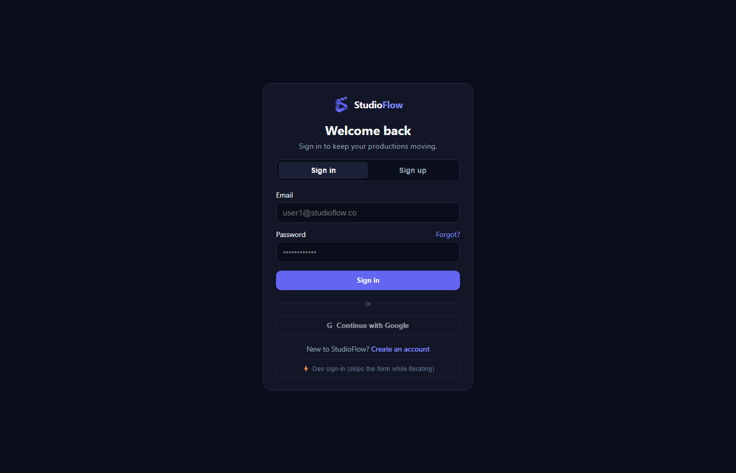
Fig. 1 — Sign in / sign up, matching the Milestone 1 mockup. The dashed button at the bottom is the dev-only shortcut described above.
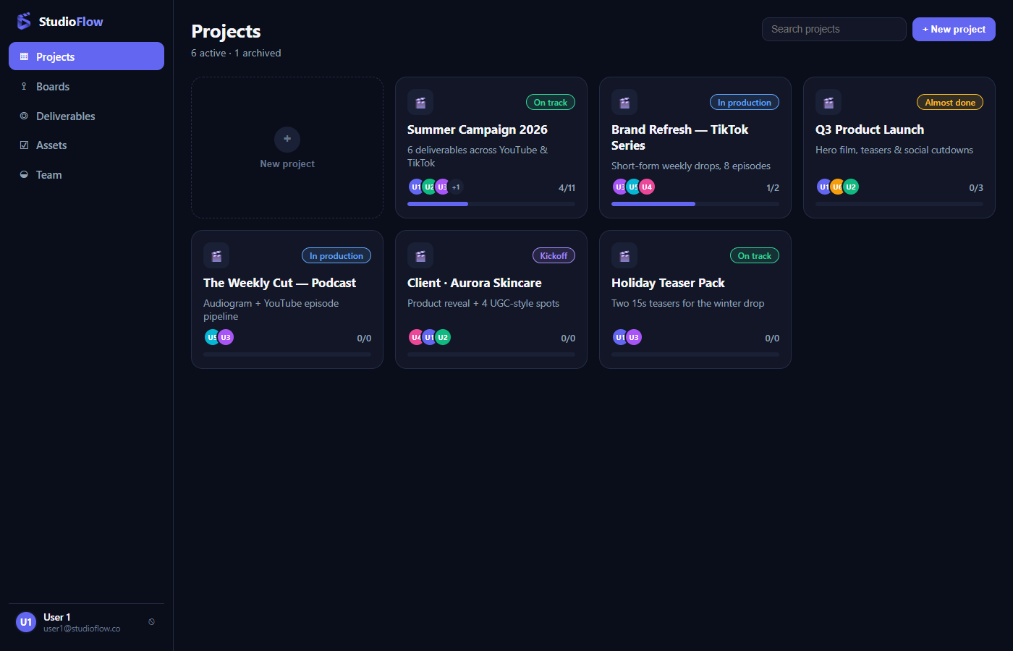
Fig. 2 — Projects dashboard: status pill, team avatars, and live progress per project.
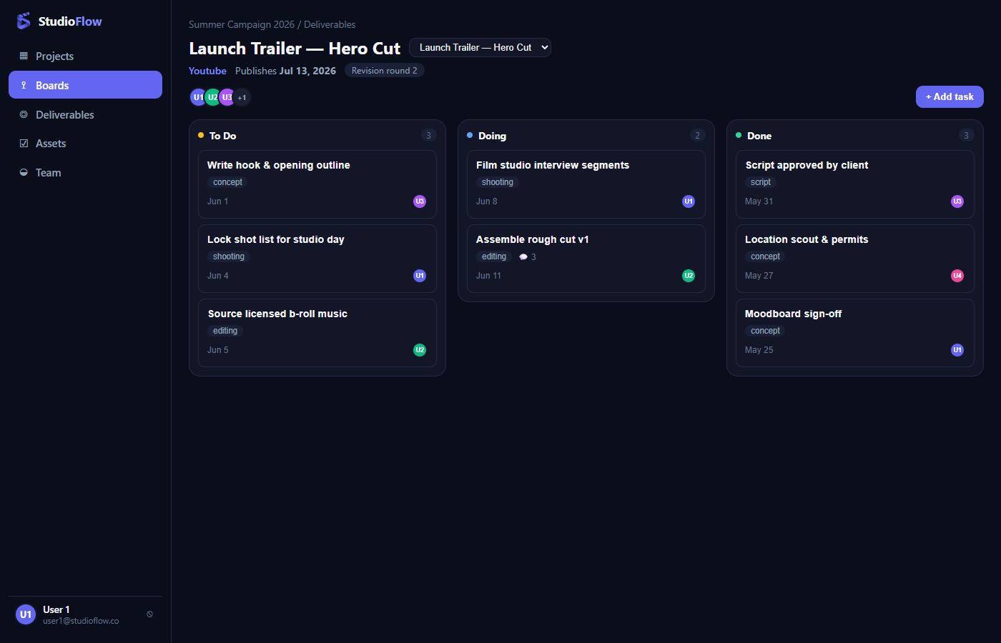
Fig. 3 — Kanban board for a deliverable, with task stage tags and due dates.
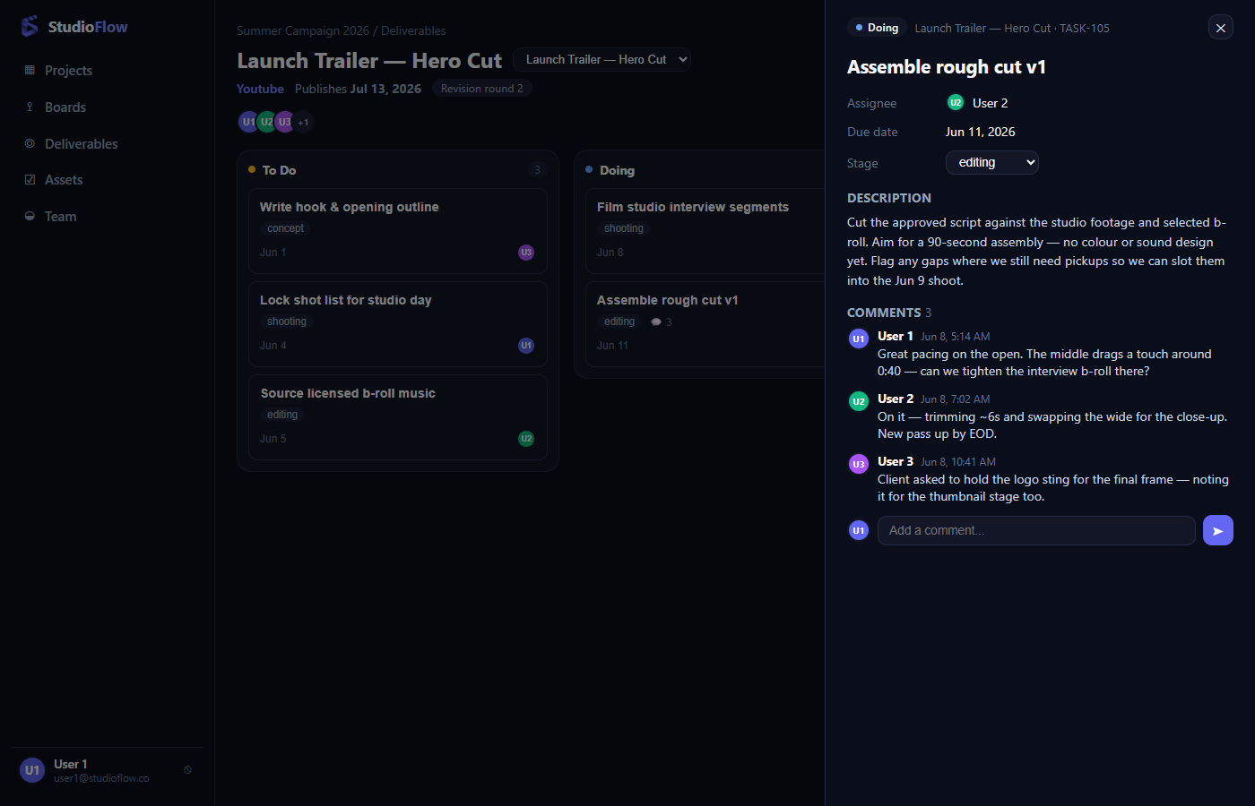
Fig. 4 — Task detail panel: editable stage, description, and a live comment thread.
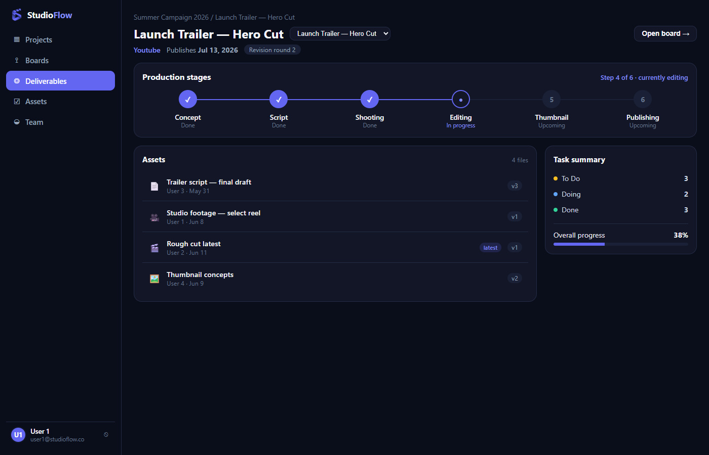
Fig. 5 — Deliverable view: production stepper computed from task stages, assets, and task summary.
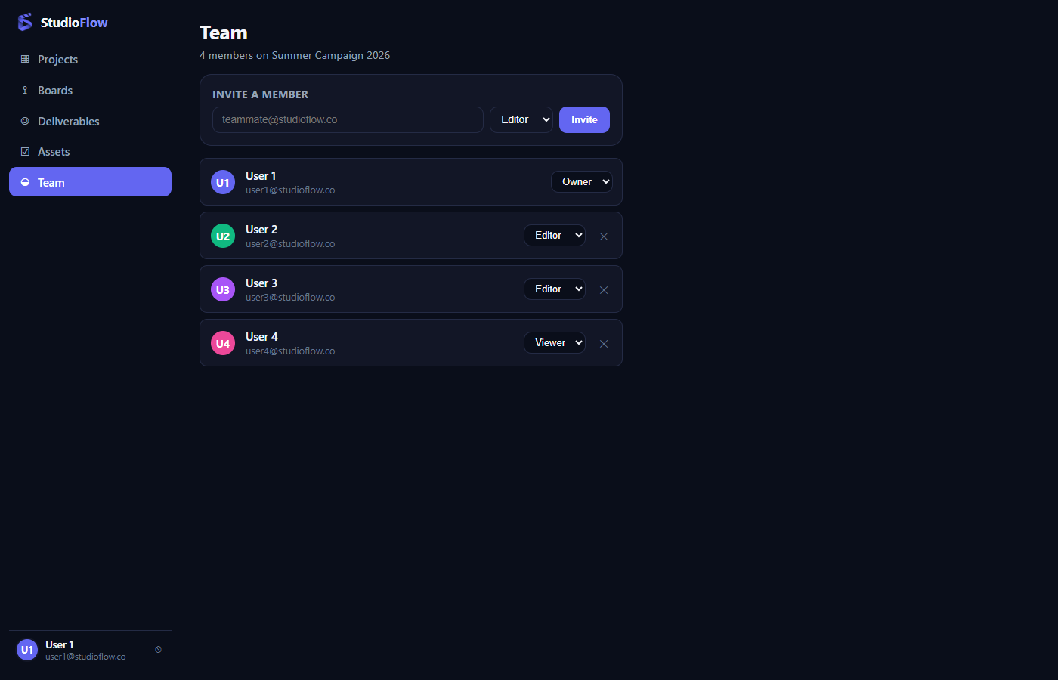
Fig. 6 — Team screen (new, no Milestone 1 mockup): member list, roles, and invite form.
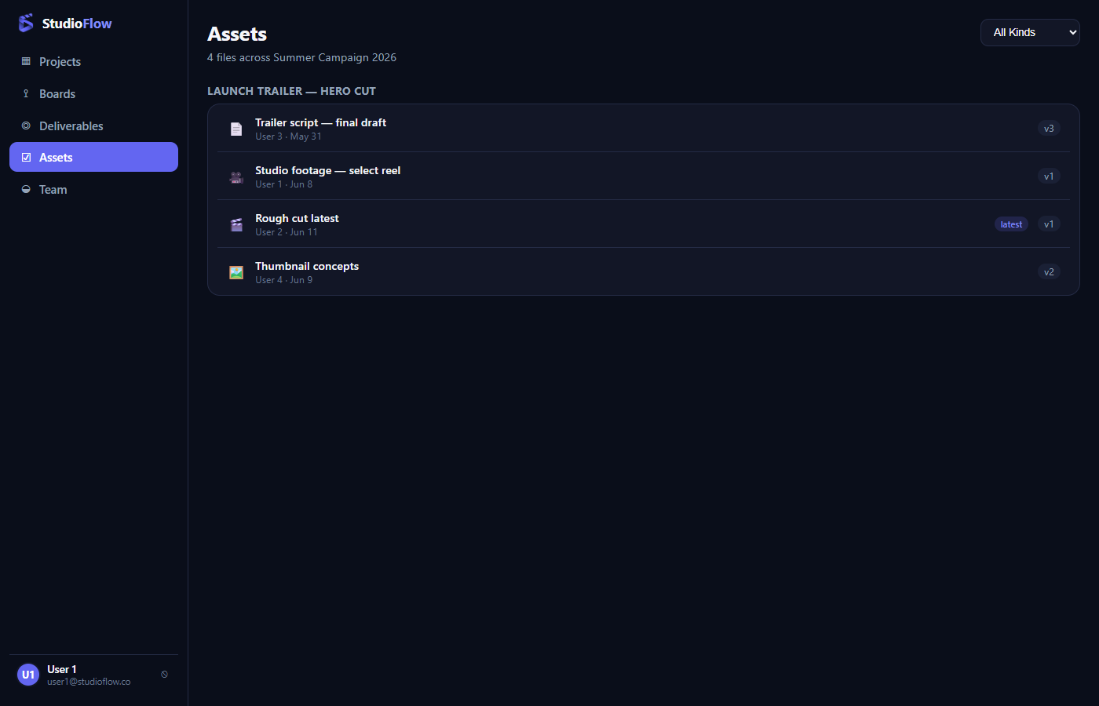
Fig. 7 — Project-wide Assets view, grouped by deliverable with a kind filter.

3. Project Plan Update
Task distribution is unchanged from Milestone 1:
Person | Vertical | Scope | Tables
Raphaël | Auth & Team | Sign up / sign in, token sessions, Google sign-in, member roles | users, accounts, refresh_tokens, project_members
Théodore | Boards & Tasks | Kanban board, task detail, comments | tasks, comments
Guillaume | Projects & Deliverables | Projects dashboard, deliverable view | projects, deliverables, assets

Step | Target | Content
Milestone 1 | Oct 2026 | Problem statement, ERD, mockups, project plan — done
Milestone 2 | Nov 2026 | Complete front-end on GitHub — this document
Back-end — API + DB per vertical | Late Nov 2026 | Node.js routes, MySQL queries per vertical
Front/back integration + testing | Early Dec 2026 | Full wiring, bug fixes
Milestone 3 | Mid Dec 2026 | Complete back-end, presentation (5–7 min)

4. Code Submission
All front-end code lives in frontend/ at the root of our repository:
github.com/ElpharienPY/StudioFlow
- Stack: Vue 3 + Vite, Vue Router, plain CSS (see Section 1).
- Run locally: cd frontend && npm install && npm run dev
- Mock data and conventions are documented in frontend/README.md.
This document was put together with the help of Claude Code, which also helped with parts of the front-end code.

